AI ASSISTEDCODINGLAB

ASSIGNMENT2.4

ENROLLMENTNO:2503A51L33

BATCH NO: 20

NAME:ThirumalakondaShiva

TASKDESCRIPTION1:OpenGoogle Colab anduseGoogleGemini to generate Python code that performs sorting of a list using both the bubble sort algorithm and Python’s built-in sort () function. Compare the two implementations.

PROMPT 1:Generate Python code that demonstrates sorting a list using two methods: (1) implementing the bubble sort algorithm manually, and (2)usingPython’sbuilt-insort()function.Thecodeshould generatea random list of integers, apply both sorting methods, and print the sorted results for comparison. Also, compare their performance (execution time) and explain the differences briefly.

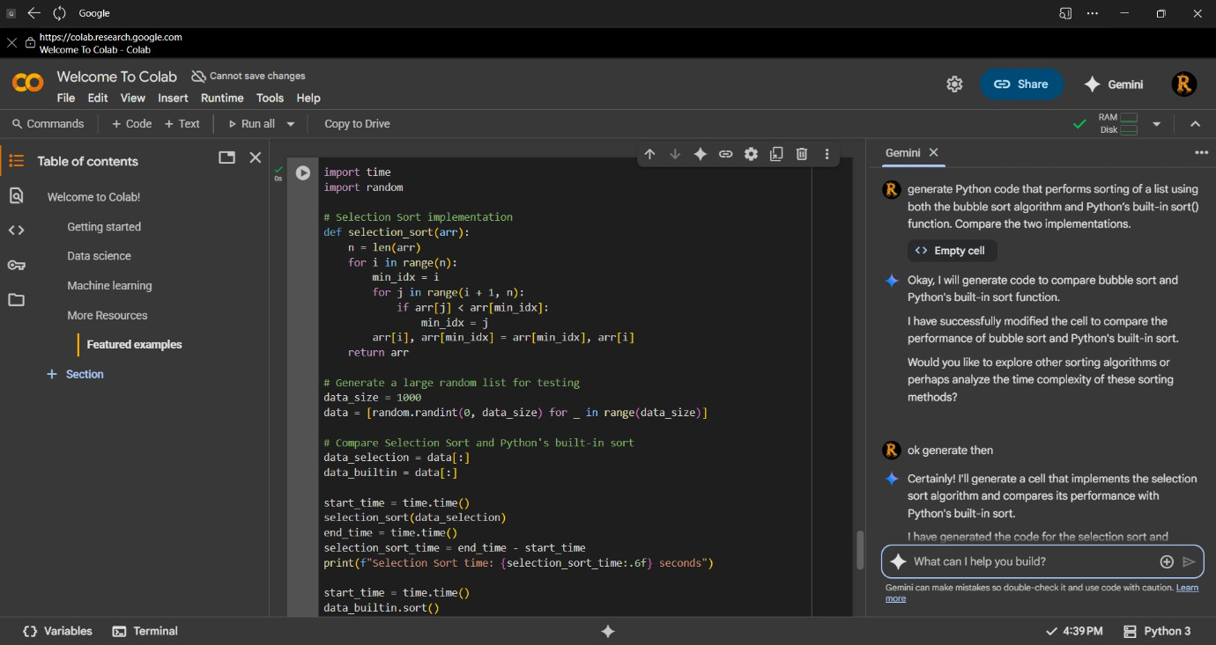

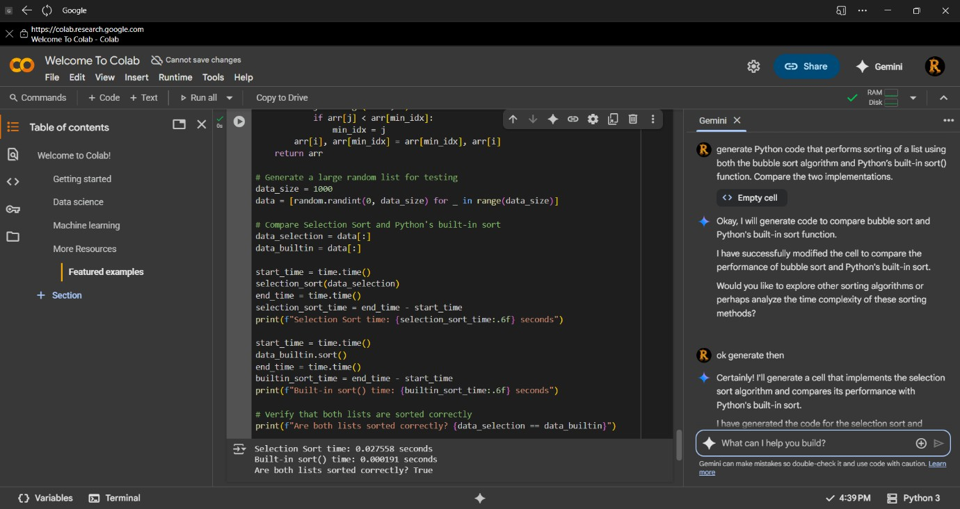

TASKDESCRIPTION 2:In Colab,useGoogleGeminitogeneratea Python function that takes a string and returns:

Thenumberofvowels, Thenumber ofconsonants,Thenumberofdigits in the string

PROMPT 1: Generate a Python function that takes a string as input and returns three values: (1) the number of vowels in the string, (2) the numberofconsonants,and (3)thenumberof digits.Thefunctionshould handle both uppercase and lowercase letters. Demonstrate the function with a few example strings.

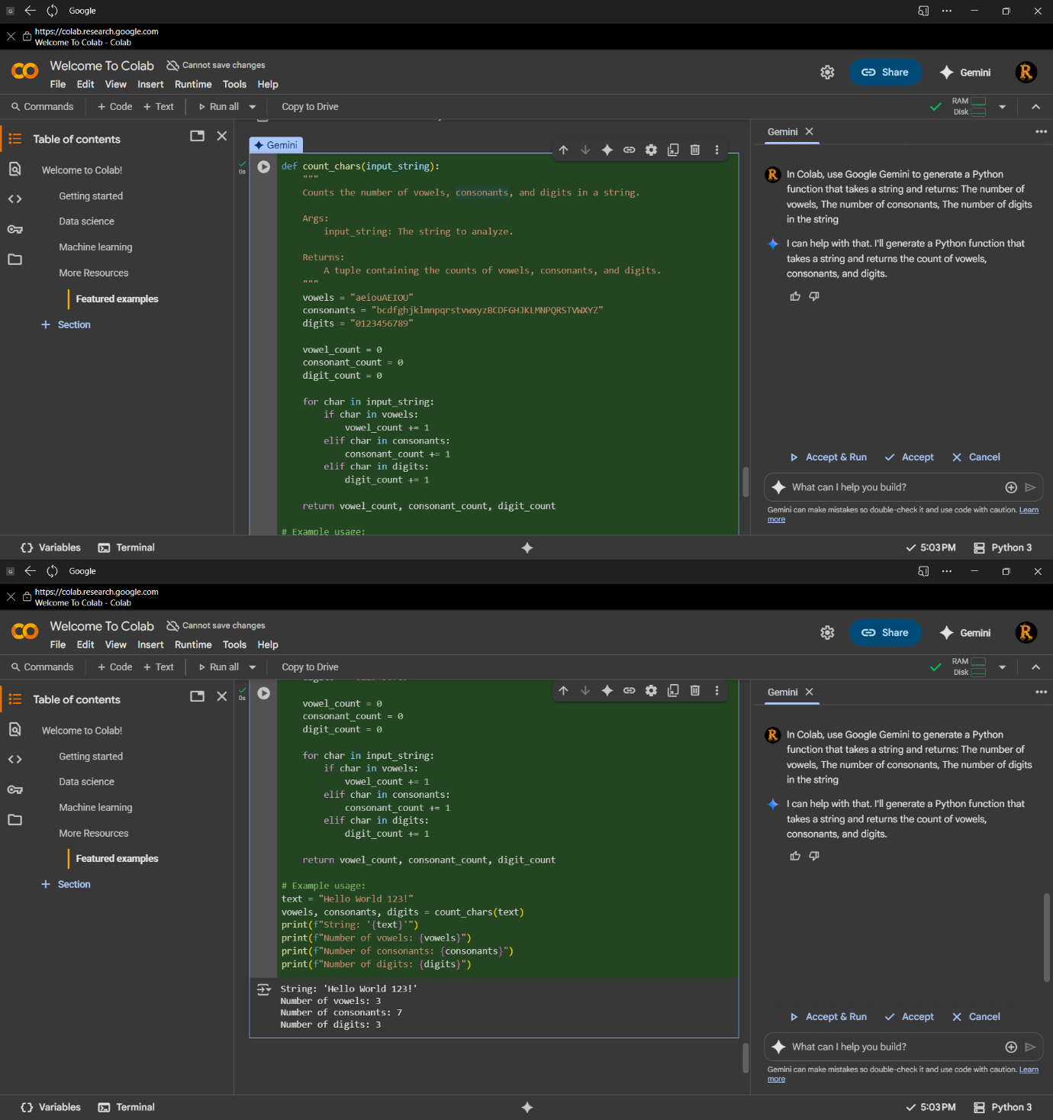

TASKDESCRIPTION4:AskGoogleGeminitogenerateaPython program that implements a simple calculator using functions (add, subtract, multiply, divide). Then, ask Gemini to explain how the code works.

PROMPT 1: Generate a Python program that implements a simple calculator using functions for addition, subtraction, multiplication, and division. The program should allow the user to enter two numbers and select anoperation. Afterwritingthecode,explainstepbystephowthe program works.

